Case 5-A394-Asia-China-Laionhe Valley-Four Horse Notched Disc-Jade-Shang-1200 BCE

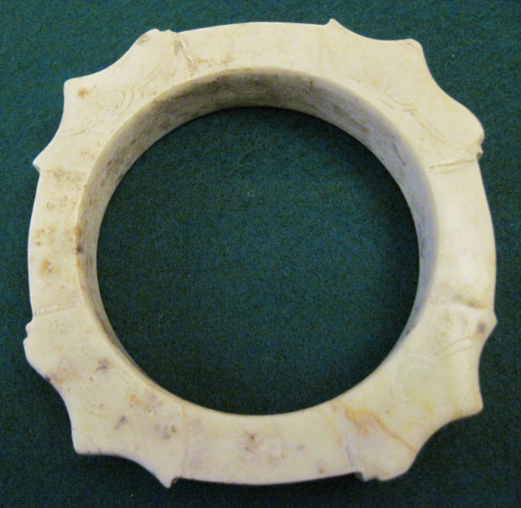

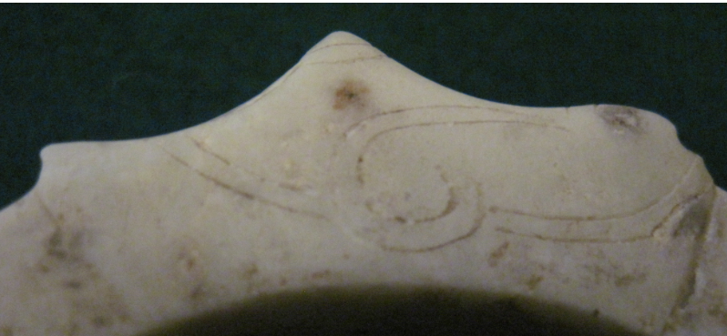 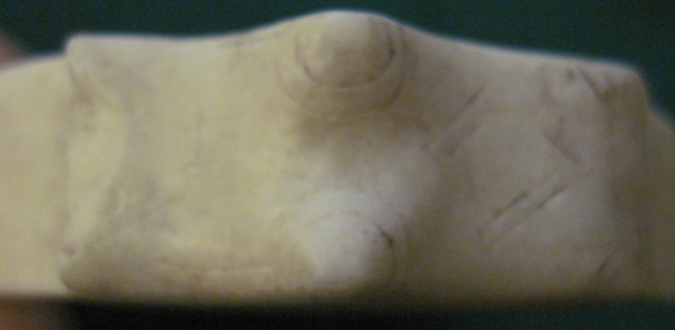

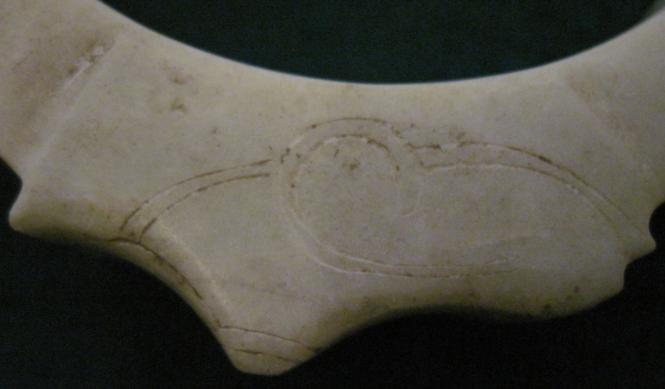Notch 1

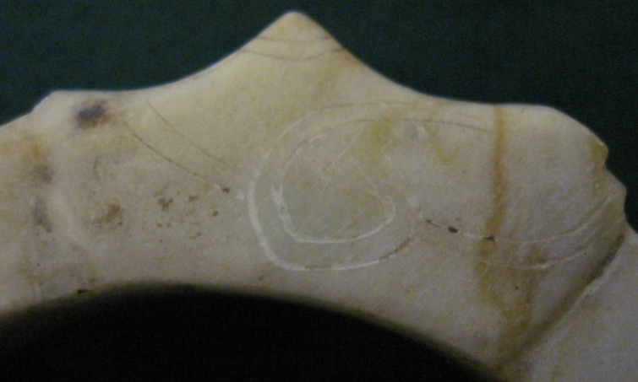 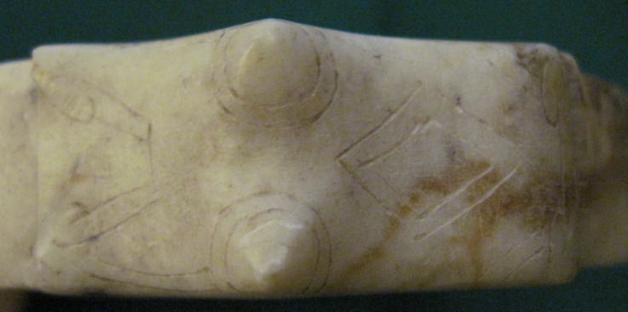

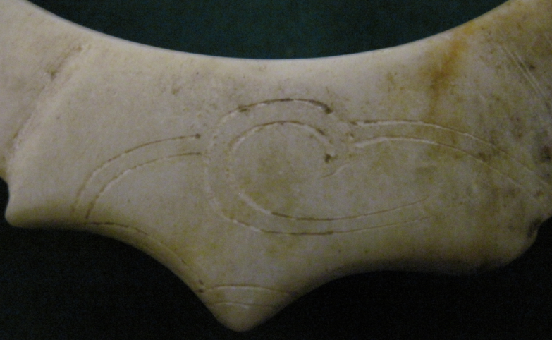 Notch 2

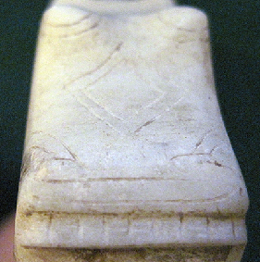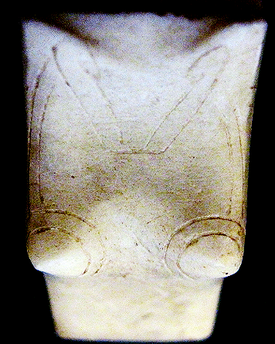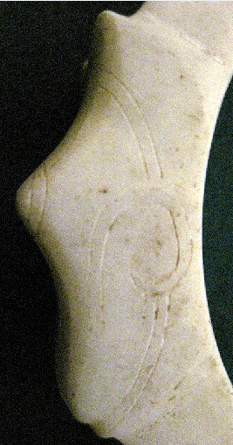

Notch 3

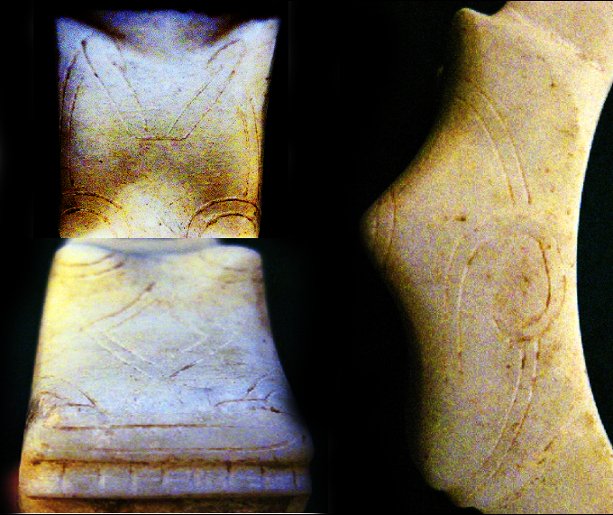

Notch 4

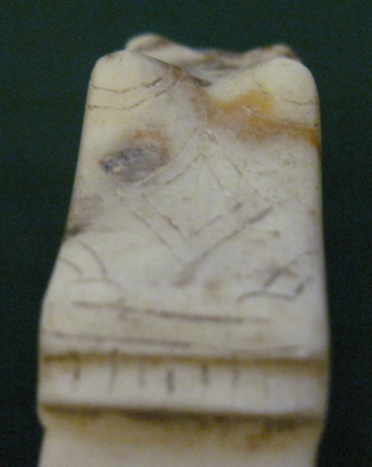 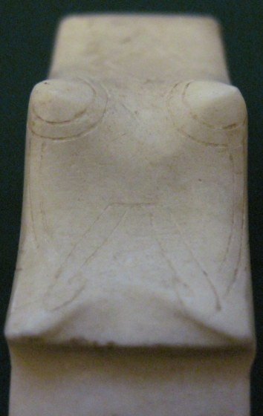 Notch 1

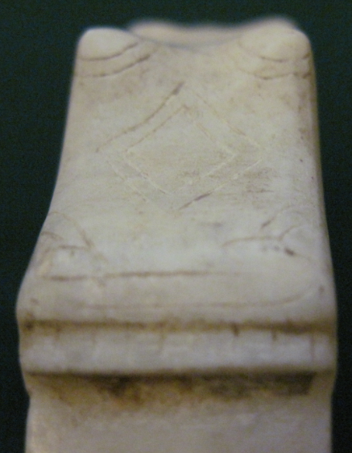 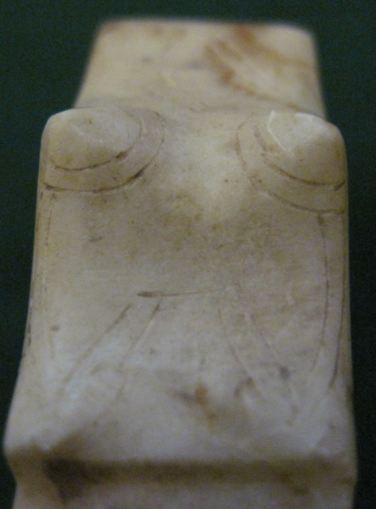Notch 2

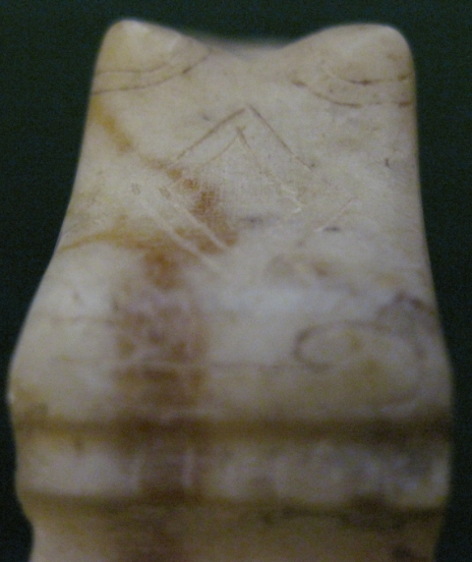 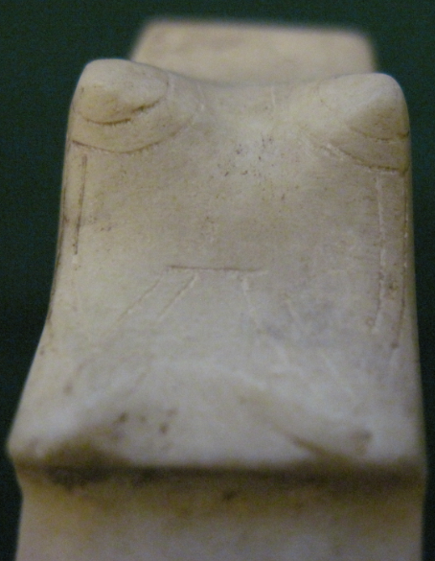Notch 3

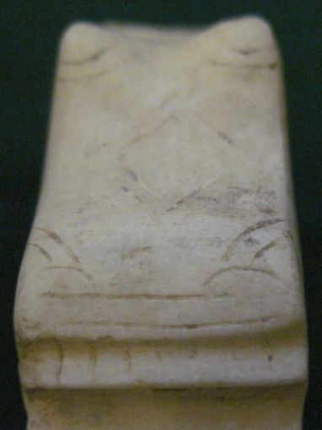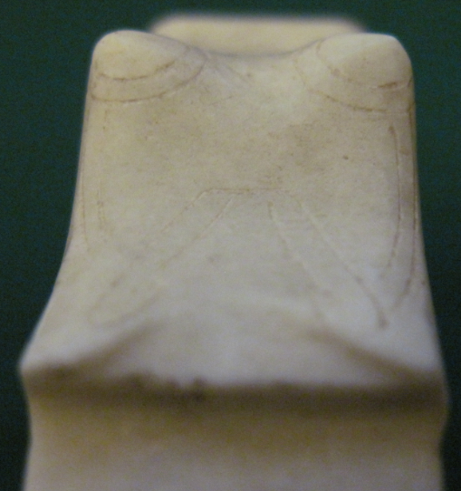Notch 4

Asia-China-Laionhe Valley-Four Horse Notched Disc-Jade-Shang-1200 BCE

**Case No.: 5**

**Accession Number: A394**

**Formal Label:** Asia-China-Laionhe Valley-Four Horse Notched Disc-Jade-Shang-1200 BCE

**Display Description:**

The notched disc originated in the Hongshan culture ca 5000 BCE in the Laiohe Valley in northeastern China. The initial design incorporated three notches which may have had an astronomical significance, but by the Shang Period the disc became associated with the domestication of the horse. The number of notches was expanded to four, since four horses were necessary to pull the heavy early Chinese war chariot. Each notch was indicated by engraved and sculpted horseheads, complete with bridals, cheek-and bit-pieces.

**LC Classification:**

**Date or Time Horizon:**

**Geographical Area:** Laiohe Valley

**Map:**

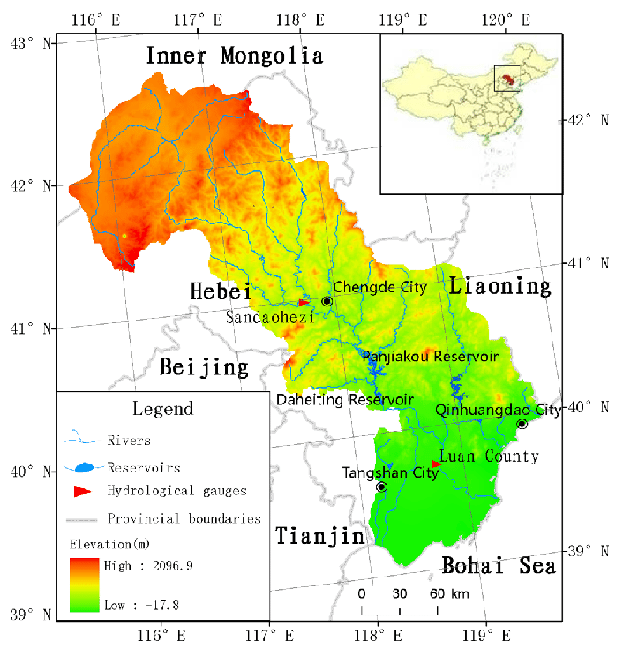

The Laiohe Valley after Yan, D & Wang, Gang & Wang, Hong & L. Qin, T. (2012). Assessing ecological land use and water demand of river systems: A case study in Luanhe River, North China. Hydrology and Earth System Sciences. 16. 2469-2483. 10.5194/hess-16-2469-2012.

**GPS Coordinates:**

**Cultural Affiliation:**

**Medium:** jade

**Dimensions**:   
**Weight:**

**Provenance:**

**Condition: orginal**

**Discussion:**



An artist’s conception of a four-horse (two team) Chinese war chariot after https://i.pinimg.com/originals/1e/7c/ba/1e7cba7ad2a20b8b93f8441501f4efdb.jpg

**References**

Allan, Sarah. 2007. “Erlitou and the Formation of Chinese Civilization: Toward a New Paradigm”. The Journal of Asian Studies 66: 2, 461-496.

Anthony, David W. 2007. The Horse, the Wheel, and Language: How Bronze-Age Riders from the Eurasian Steppes Shaped the Modern World. Princeton: Princeton University Press.

Anthony, David W.; Brown, Dorcas R.; George, Christian. 2006. "Early horseback riding and warfare: the importance of the magpie around the neck". In Olsen, Sandra L.; Grant, Susan; Choyke, Alice; Bartosiewicz, Laszlo. Horses and Humans: The Evolution of the Equine-Human Relationship. British Archaeological Reports International Series. 1560. Oxford: Archaeopress.

Anthony, David W.; Telegin, Dimitri; Brown, Dorcas. 1991. "The origin of horseback riding". Scientific American 265: 6, 94-100.

Cai, Dawei, Zhuowei Tang, Lu Han, Camilla F. Speller, Dongya Y. Yang, Xiaolin Ma, Jian’en Cao, Hong Zhu, and Hui Zhou. 2009. “Ancient DNA Provides New Insights into the Origin of the Chinese Domestic Horse.” Journal of Archaeological Science 36, no. 3 (March): 835-842.

Chinese Academy of Social Sciences, Institute of Archaeology ed.2003. Yinxu Huayuanzhuang Dongdi jiagu 殷墟花園莊東地甲骨. Kunming: Yunnan Renmin Chubanshe. 6 vols.

Chen Mengjia 陳夢家. 1988. Yinxu buci zongshu 殷虛卜辭綜述. Beijing: Zhonghua Book Company.

Dewall, Magdalene von. 1964. Pferd and Wagen im frühen China. Saarbrücken: 224 Saarbrücker Beitrage zur Altertumskunde.

Didier, John C. 2009. “In and Outside the Square: The Sky and the Power of Belief in Ancient China and the World, c. 4500 BC - AD 200. Vol. 1: The Ancient Eurasian World and the Celestial Pivot”. Sino-Platonic Papers 192, September 20.

Falkenhausen 2006 Falkenhausen, Lothar von. Chinese Society in the Age of Confucius (1000-250 BC): the Archaeological Evidence. Los Angeles : Cotsen Institute of Archaeology Press.

Kelekna, Pita. 2009. The horse in human history. New York: Cambridge University Press.

Shaughnessy, E. 1988. “Historical perspectives on the introduction of the chariot into China”. Harvard Journal of Asiatic Studies 48, 189-239.

Shaughnessy, E. 1991. Sources of Western Zhouhistory: Inscribed bronze vessels. Berkeley and Los Angeles: University of California Press.

Shaughnessy, E. 1999. “Western Zhou History”, in Michael Loewe and Edward L. Shaughnessy eds., The Cambridge History of Ancient China: from the Origins of Civilization to 221 BC. Cambridge: Cambridge University Press, 292-351.

Shelach, Gideon. 1999. Leadership Strategies, Economic Activity, and Interregional Interaction: Social Complexity in Northeast China. New York, Kluwer Academic /Plenum Press.

Shelach, Gideon. 2004. “Early pastoral societies of Northeast China: Local change and interregional interaction during c. 1100 to 600 BC”, in R. Amitai and M. Biran eds., Mongols, Turks and others: Eurasian nomads and the outside world. Leiden: Brill, 15-58.

Shelach, Gideon. 2009. Prehistoric societies on the northern frontiers of China: Archaeological perspectives on identity formation and economic change during the first millennium BCE. London; Oakville, CT: Equinox Publishing Ltd.

Shelach, Gideon and Yuri Pines. 2008. “Power, identity and ideology: Reflections on the formation of the State of Qin (770-221 BCE)”, in An Archaeology of Asia, ed. M. T. Stark. Oxford: Blackwell, 202-230.

Wan, Xiang. 2013. The Horse in Pre-Imperial China. U. Penn. Ph. D. diss.

Wu Xiaoyun 2009. Shangzhou shiqi chema maizang yanjiu 商周時期車馬埋葬研究. Beijing: Kexue Chubanshe.